Debugging Exercise 1: Array Manipulation

Objective: To identify and fix errors in a Java program that manipulates arrays.  
  
public class Array Manipulation {

    public static void main(String[] args) {

        int[] numbers = {1, 2, 3, 4, 5};

        for (int i = 0; i <= numbers. Length; i++) {

            System.out.println(numbers[i]);

        }

    }

}

In this given task code the issue is the looping statement, the arrays in java are zero-indexed which means the first element is at index 0 and iterates till the last element numbers.length-1.

The problem for this code is sorted if we change the looping condition by removing the “=” symbol.

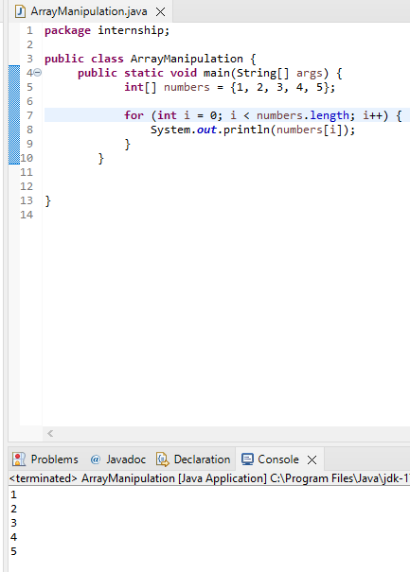

Debugging Exercise 2: Object-Oriented Programming

Objective: To identify and fix errors in a Java program that demonstrates basic object-oriented programming principles.  
  
class Car {

    private String make;

    private String model;

    public Car(String make, String model) {

        this.make = make;

        this.model = model;

    }

    public void start() {

        System.out.println("Starting the car.");

    }

}

public class Main {

    public static void main(String[] args) {

        Car car = new Car("Toyota", "Camry");

        car.start();

        car.stop();

    }

}

Error:

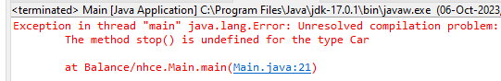

This was the error defined for the ex.2 ,as we can see in the Main class we are trying to call the stop() method on car object, but the stop() method is not defined in the Car class, so to resolve this we can add a stop method to the Car class

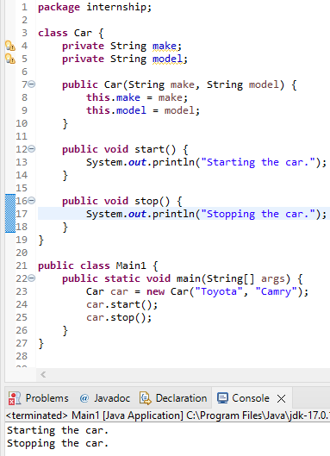

Debugging Exercise 3: Exception Handling

Objective: To identify and fix errors in a Java program that demonstrates exception handling.

public class ExceptionHandling {

    public static void main(String[] args) {

        int[] numbers = {1, 2, 3, 4, 5};

        try {

            System.out.println(numbers[10]);

        } catch (ArrayIndexOutOfBoundsException e) {

            System.out.println("Array index out of bounds.");

        }

        int result = divide(10, 0);

        System.out.println("Result: " + result);

    }

    public static int divide(int a, int b) {

        return a / b;

    }

}

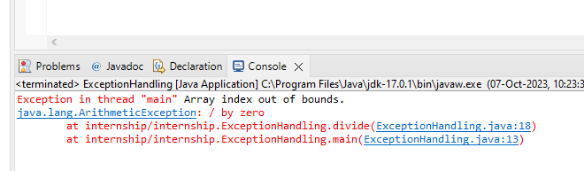

We can see the 1st error message in this code is Array index out of bounds. The code tries to access the 10th element from the numbers array which is out of bound ,so when we run the program the try and catch block is used to handle the exception and array index out of bounds is printed

The 2nd error message in this code is an ArithmeticException, its not effective to divide by zero in Java so a try-catch block can be added to the main method and since zero is not allowed we can add a condition to the divide method that if b==0 before performing division and we can throw an ArithmeticException printing divison by zero is not allowed

